Thayer’s Gull Larus thayeri (first cycle)

Location: Niles Pond, Gloucester

Date: December 27, 2014

Observers: Nick Bonomo (author of this writeup; photos), Julian Hough (finder; photos), Greg Hanisek

Optics/Equipment:
Swarovski EL 8.5x42 binoculars
Kowa 883 spotting scope w/ 20-60x zoom eyepiece
Canon Powershot A590-IS digital camera

Weather: Clear skies, light wind, unseasonably warm temperatures

Discovery: As we were standing along the dike between Niles Pond and Brace Cove, Julian spotted and called out an interesting young gull as it flew over us heading from the cove to the pond. He suspected the bird as a Thayer’s candidate. We watched as the bird banked and landed on the pond, where it proceeded to bathe for 10-15 minutes. We immediately walked a bit down the road to an opening in the vegetation through which we could more closely observe the bird. The bright sun was to our left as we were watching the bird ahead. We studied, discussed, and attempted to photograph the bird. Solid identification was made quickly thanks to very good views through high-powered scopes and the bird’s active behavior which allowed us to repeatedly observe the salient features. Of course the identification of this controversial taxon was not taken lightly, but this being a textbook THGU made what can be a tricky identification rather straightforward for these experienced birders.

Description:
From GH’s eBird report:
“medium-sized Larus gull; juvenile superficially resembling juv. Herring Gull, but more crisply patterned overall (checkered look); slender all-dark bill; rounded head; slightly masked appearance; folded primaries dark brown with pale tip edges; dark-centered tertials; open wings with two-toned outer primaries and dark secondary bar on dorsal surface; under surface of primaries silvery with dark tips to outers; broad dark band on spread tail; strongly barred under tail coverts”

Also of note:
- No active molt apparent with all scapulars of juvenile generation
- I would describe the tail as almost entirely brown, rather than banded
- Dark primary coverts
- Photos show subtle paling to the base of the bill

Separation from Similar Species:
“Kumlien’s” Iceland Gull:
- Iceland Gull molts its juvenile scapulars earlier, on average, than Thayer’s. Our bird has entirely juvenile scaps.
- The tertials of an Iceland Gull are largely or entirely marbled and rarely contrast with the mantle color. This bird has dark-centered and mid-brown tertials.
- The dark-brown primaries of our bird are obviously darker than the rest of the upperparts and have thin whitish fringes at the tip. Dark first-cycle Iceland Gulls, or possible intergrades, can show contrastingly dark primaries as well, but they are often darkest in the sub-apical part of the feather tip. Our bird’s primaries are evenly dark throughout their tip and outer web. This “Venetian blind” look is classic for Thayer’s Gull and outside the range of “Kumlien’s” Iceland Gull.
- Dark primary coverts are also a pro-thayeri feature versus kumlieni
- In flight, Iceland Gull should show neither a dark secondary bar nor a nearly solid brown tail.

Herring Gull:
- Herring Gull also molts its juvenile scaps earlier than Thayer’s, on average. In fact, there are few Herring Gulls at this time of year that do now show at least a few first-winter scapulars.
- Size – This bird was smaller than the few HERGs it passed while bathing, and was about the size of a nearby “Kumlien’s” Iceland Gull. It should be noted that intraspecific size can vary greatly in these large gulls and, like some other features (such as scapular molt timing), should only be used as a supportive character.
- Structurally, our bird is not bulky like a standard HERG. Rather, it is built more delicately, closer to Iceland Gull than Herring Gull. Note its gently sloping pear-shaped head with rounded crown.
- A HERG’s scaps and wing coverts should not be this checkered and frosty throughout.
- Bill size is also on the small and thin end for HERG (again, HERGs are so variable).
- While the underwing of a first cycle Herring Gull can appear quite silvery-white, the outermost primaries are always slightly darker than the rest. This was not the case on our bird.
- Upperwing – In flight, Herring Gull shows mostly dark outer primaries that contrast with inner primaries, often referred to as a pale inner primary “window.” Our bird showed the “Venetian blind” look to outer primaries caused by dark brown restricted to the tips and outer webs, typical of Thayer’s Gull and outside the range of HERG.

Previous experience:
Each of us has similar experience: we have each seen several first cycle Thayer’s Gulls; a handful in the east and many in the west. We each spend several hours in the field each winter studying gulls in New England.

Photos (full-size images of higher resolution are available on request):
Photos by NB:
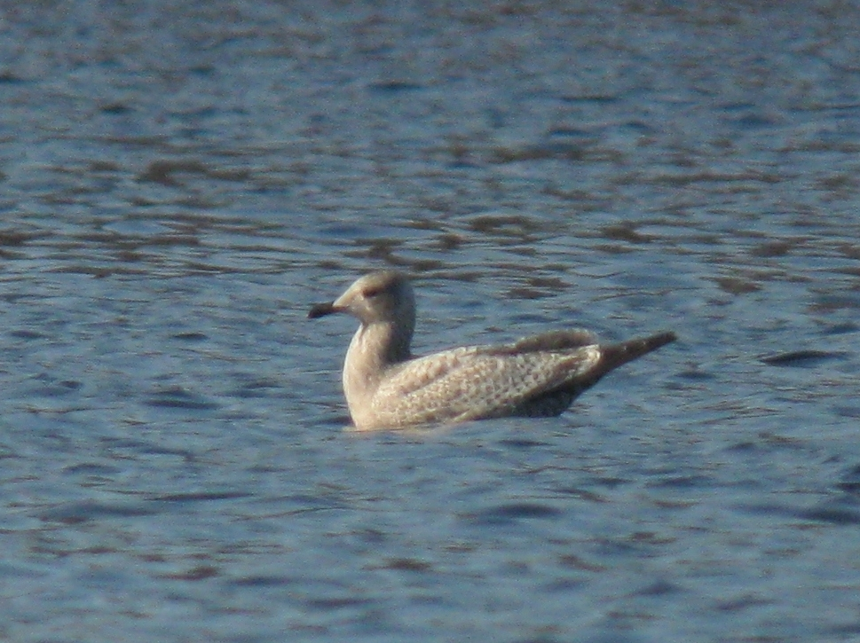
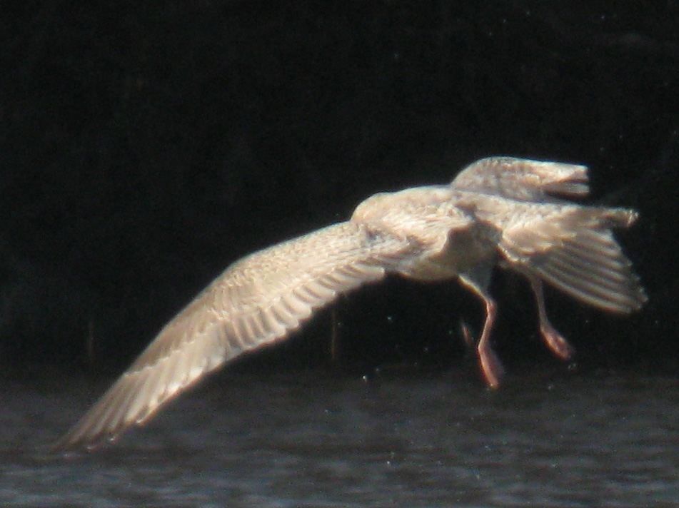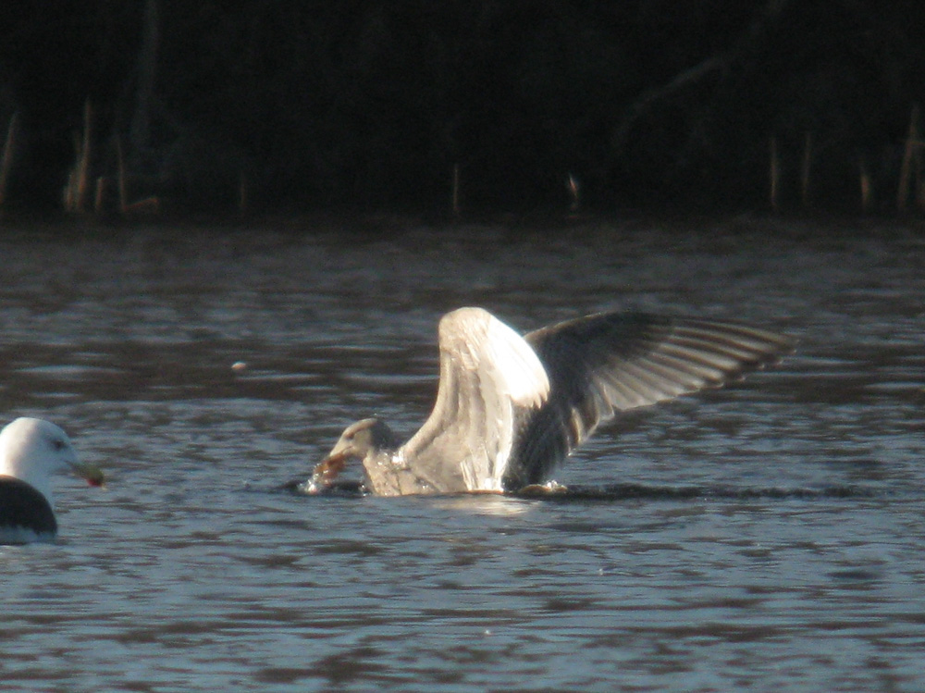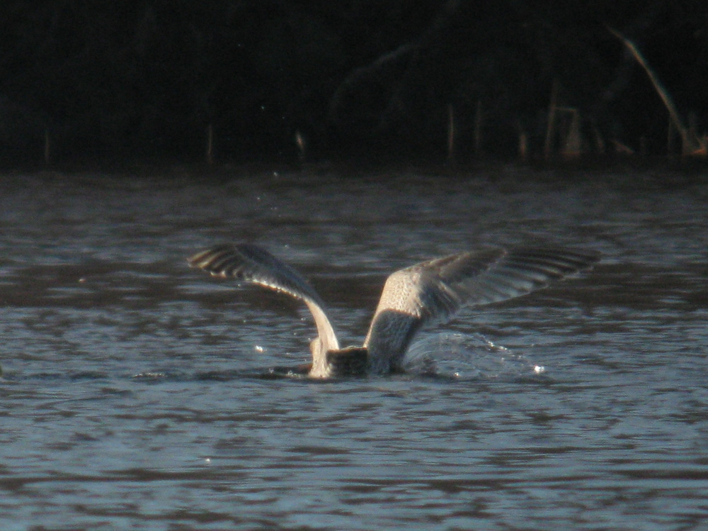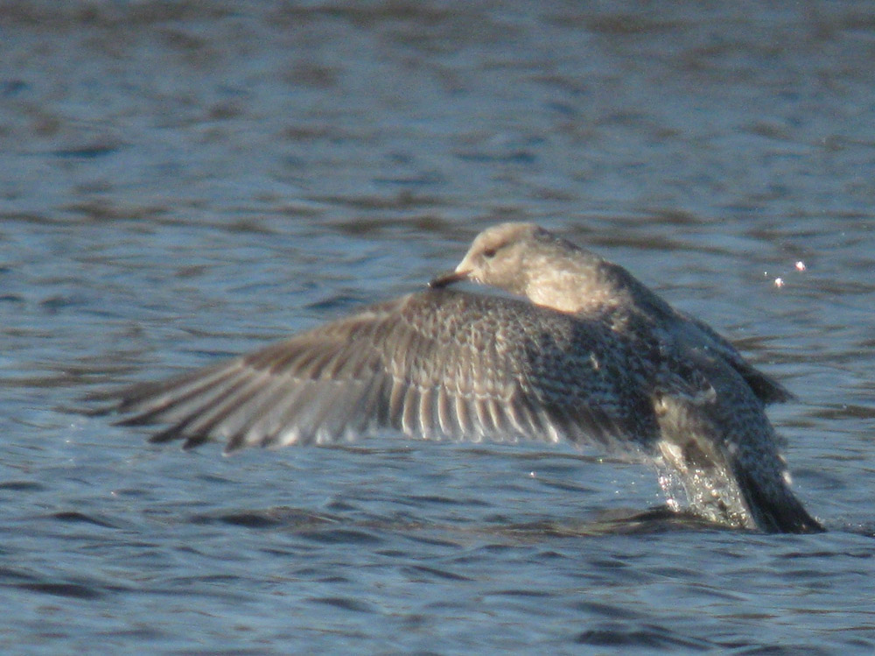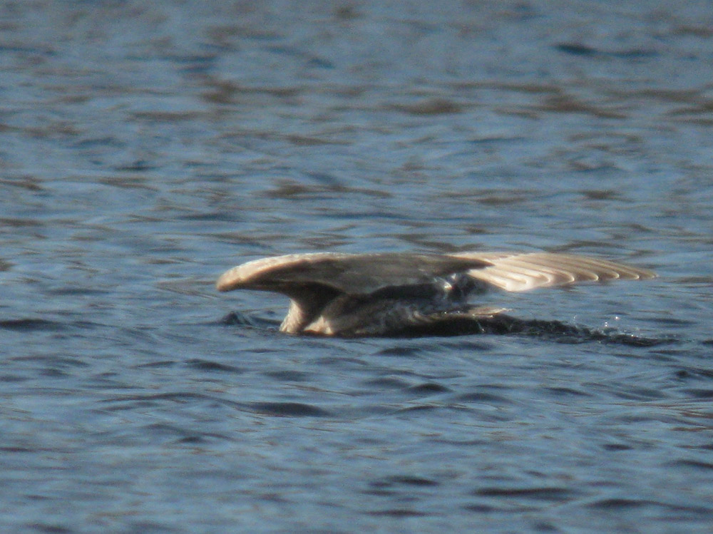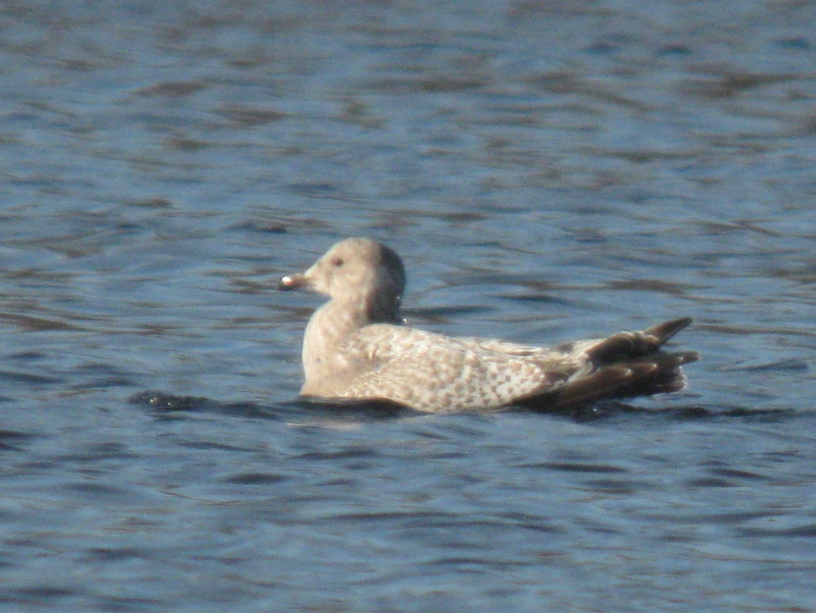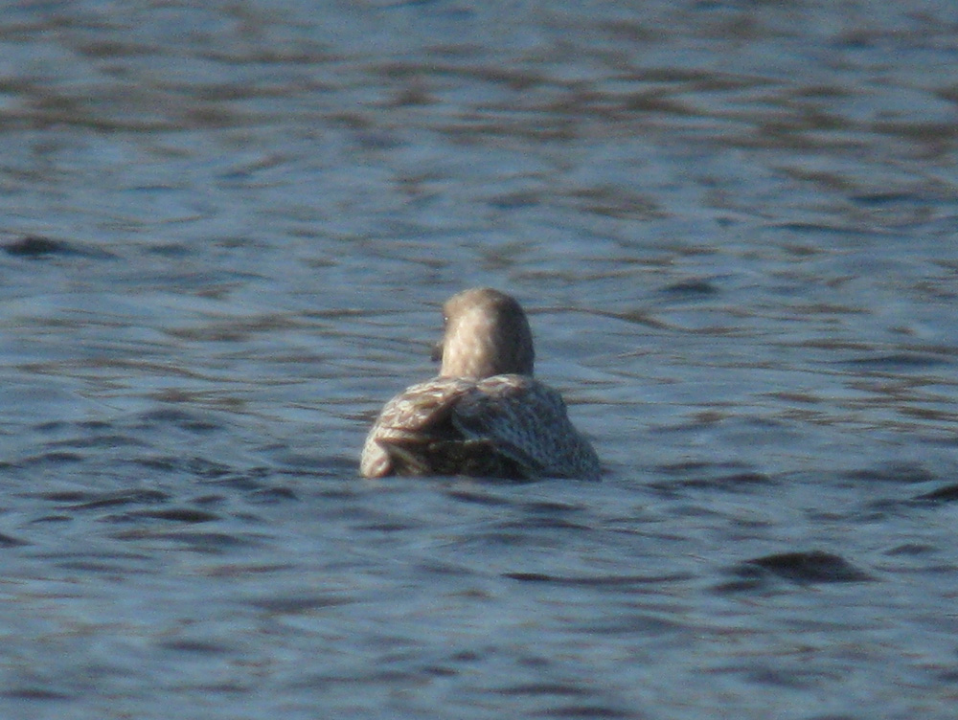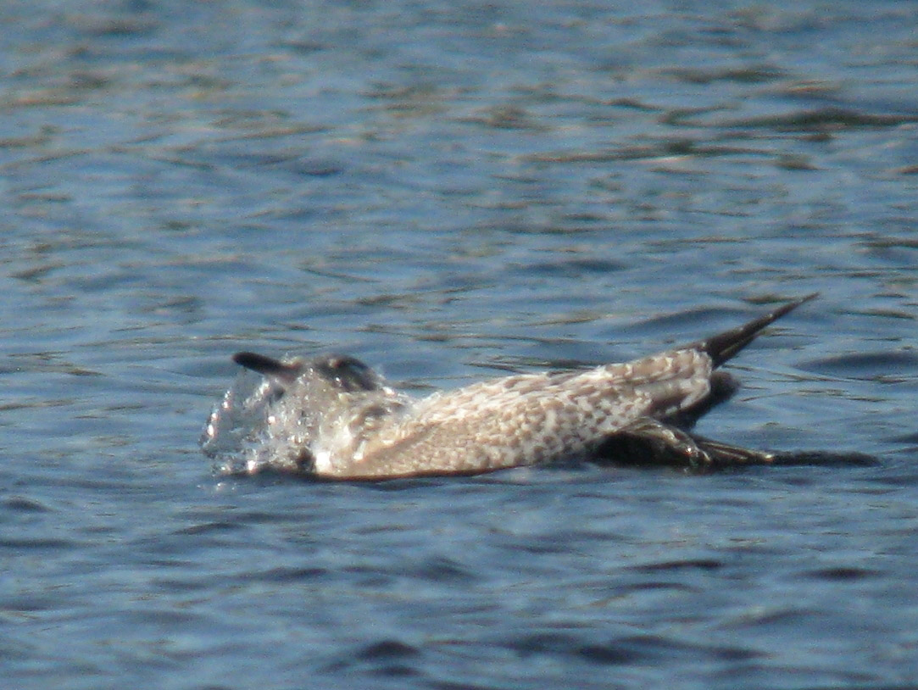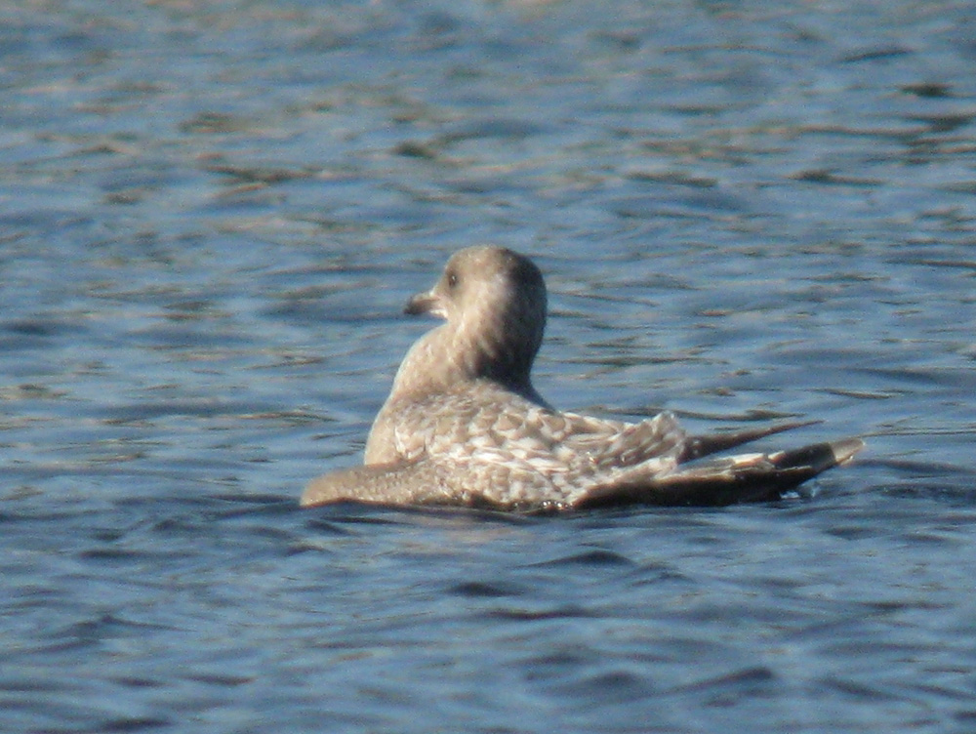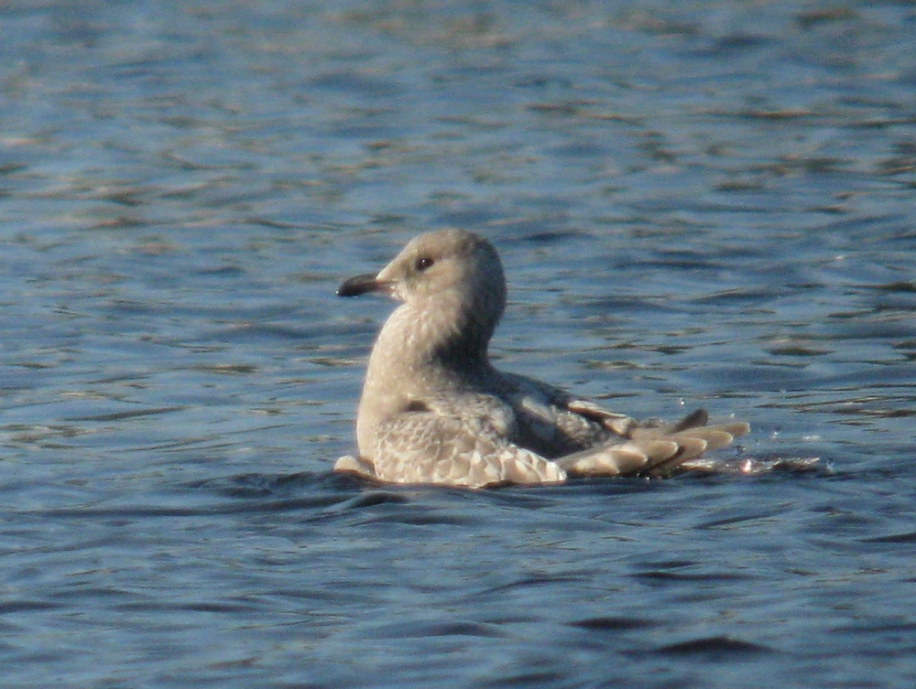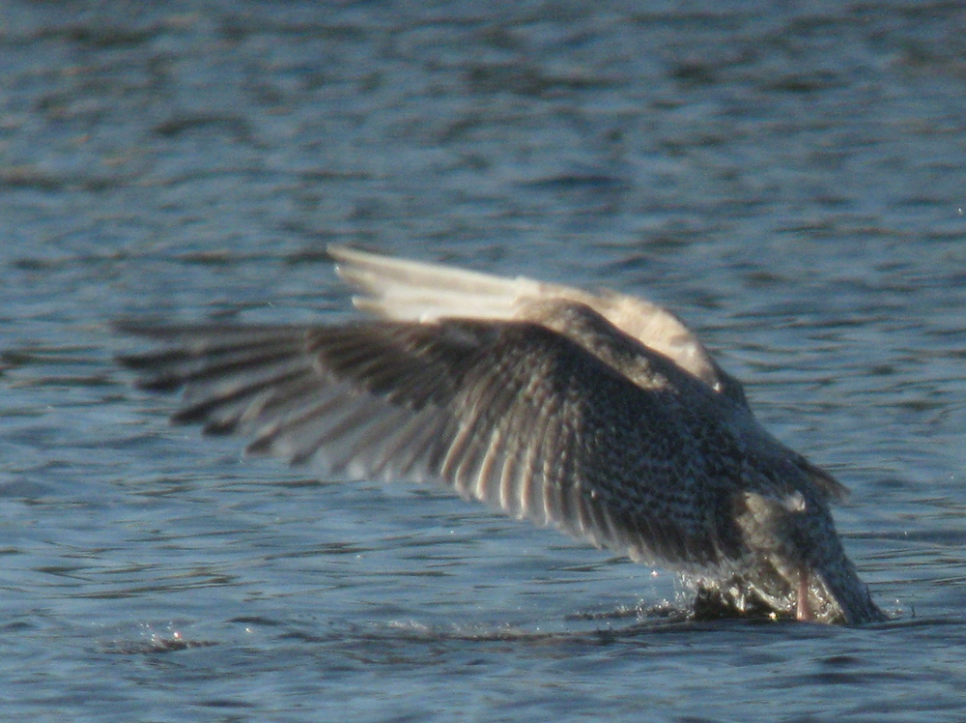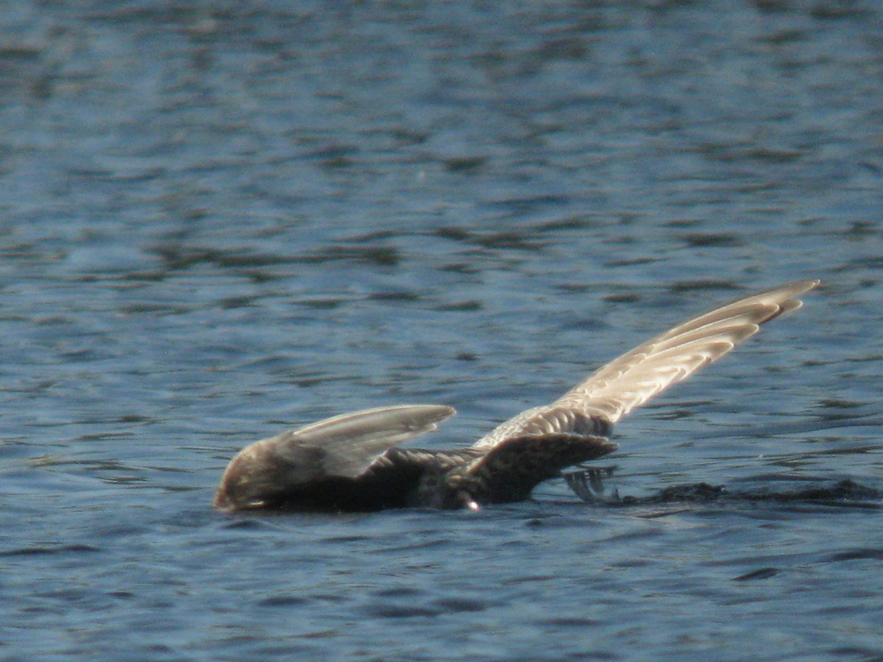

Photos by Julian Hough:
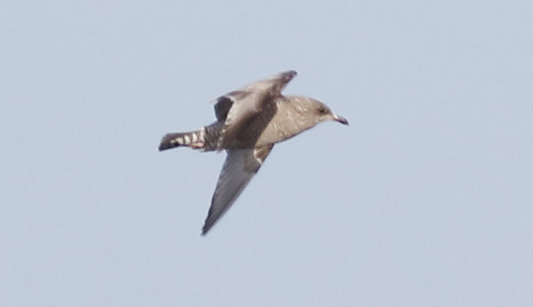
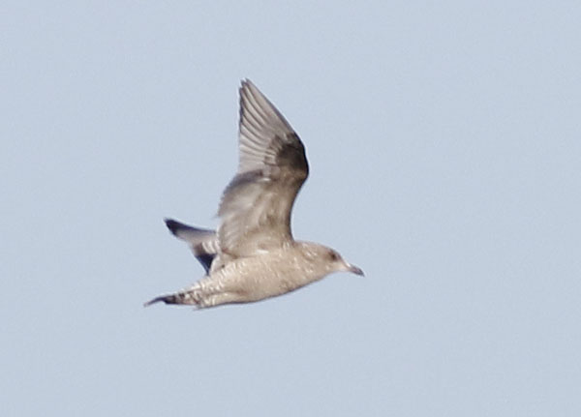

Submitted on behalf of JH, GH & NB by Nick Bonomo, 46 South Cherry Street, Unit 244, Wallingford, CT, 06492; nbonomo@gmail.com; 203-645-2059

